The experience of visiting the museum was a great one for me. I thought I learned a lot from this experience. This exhibition covers a wide range of fields such as products, architecture, digital media, etc.

In my opinion, this is not a normal museum. many normal design exhibitions usually focus on showing their content and research results, how it solves problems and how to get more business value. However, this museum placed many classic works, and many works reflect the historical and cultural background of the time.

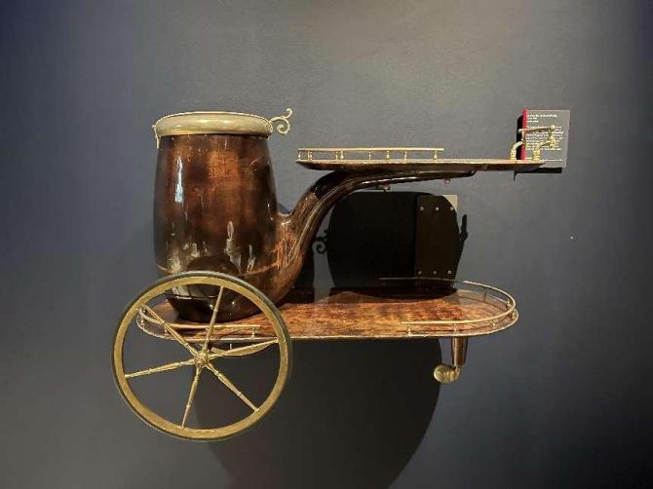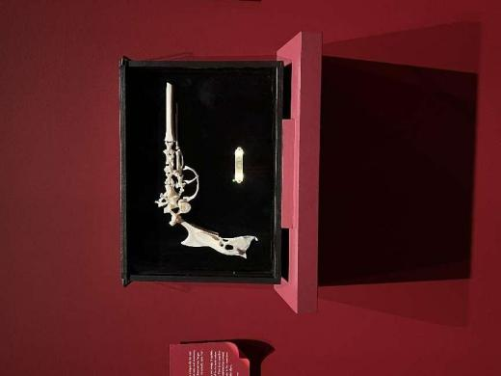

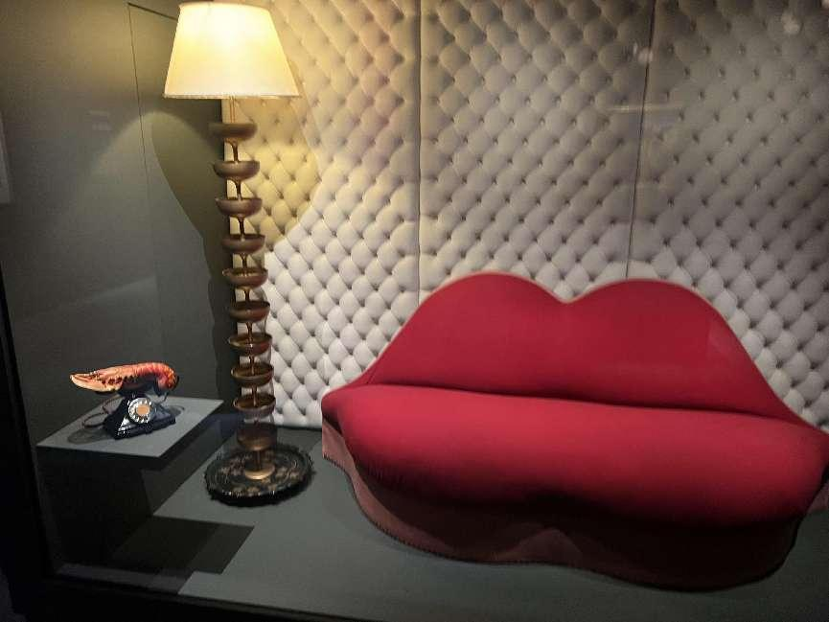

Upon seeing the design museum, I thought that they set different lighting in different exhibition halls, which was related to the background of the design works. For example, in the exhibition with some of the long history of works, they used a relatively dark environment and many spotlights to decorate, which made the atmosphere of the exhibition full of seriousness, which made me realize that I'm not in a relaxed environment. There will be a small section of text introduction next to each work, which clearly reflects the content of these works. Unlike traditional works, these works reflect the social background at that time, criticizing or strengthening the social trend at that time through these different kinds of works. These works affect the viewer's mind and cause resonance, as well as reflection.

Furthermore, if I have a chance to create my own exhibition, its name is design affects us, which means the design has discourse and power to affect audiences even the world.

Firstly, I will choose some works that are different from traditional designs and put them in this museum. For example, the evolution of architectural design styles, the development of industrial design from the last century to the present, and some design work that can reflect historical culture. Secondly, I would set a unique atmosphere for each work such as the colour of light, the colour of the wall and the layout of the environment, because I think these can enhance the expressiveness of works.

Finally, I will place works from similar periods together in one area and introduce the background of that era at the entrance to help the audience understand. I think my exhibition needs a larger space, but the viewer will have a better experience, and at the same time can strengthen the knowledge structures and existing power dynamics.

I think the arrangement of this exhibition is relatively reasonable, as the curator has placed related works together, which provides a feeling of watching a story and creating knowledge structures and existing power dynamics. For example, in the technology area, many electronic devices are neatly arranged in chronological order. I think the curator wants to bring the audience into a digital atmosphere in this way, forming a clear logic in this way to tell the audience that this is describing the process of technological development, and it guides them to have a memory of past electronic products and a vivid imagination for the future development of technology. Therefore, I think this exhibition is interesting.

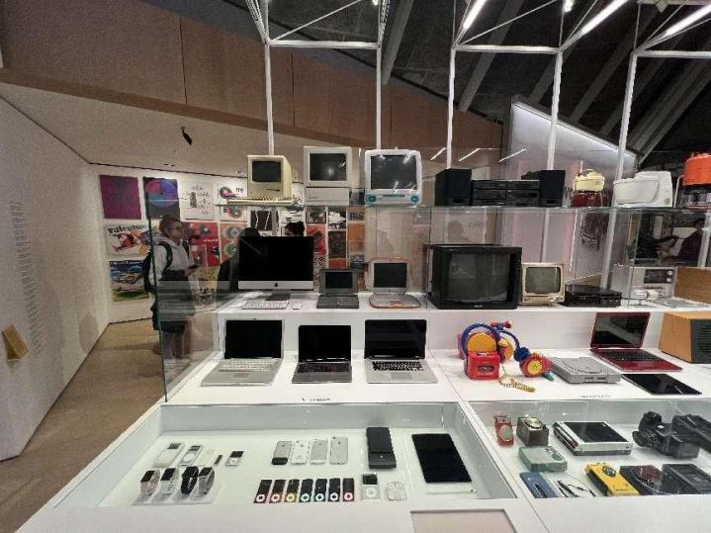

Overall, I think this exhibition experience is good, and I also learned some methods and reflections about strengthening the knowledge structure and existing power dynamics.